**EMPN1398**

**Abhishek Kushwaha**

**JavaScript Console Assignment: Task Manager (CLI Simulation)**

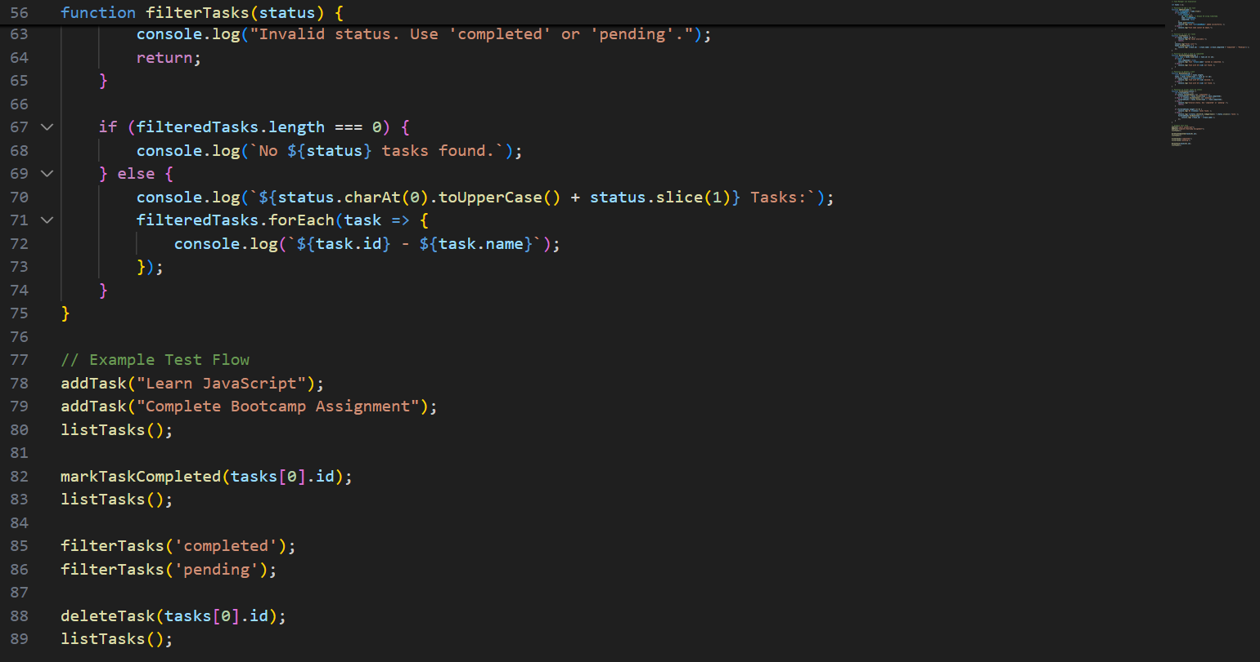

Output

**Code**

// Task Manager CLI Simulation

let tasks = [];

// Function to add a new task

function addTask(name) {

    const trimmedName = name.trim();

    if (trimmedName) {

        const newTask = {

            id: Date.now(), // Unique ID using timestamp

            name: trimmedName,

            completed: false

        };

        tasks.push(newTask);

        console.log(`Task "${trimmedName}" added successfully.`);

    } else {

        console.log("Task name cannot be empty.");

    }

}

// Function to list all tasks

function listTasks() {

    if (tasks.length === 0) {

        console.log("No tasks available.");

        return;

    }

    console.log("Tasks List:");

    tasks.forEach(task => {

        console.log(`${task.id} - ${task.name} [${task.completed ? "Completed" : "Pending"}]`);

    });

}

// Function to mark a task as completed

function markTaskCompleted(id) {

    const task = tasks.find(task => task.id === id);

    if (task) {

        task.completed = true;

        console.log(`Task "${task.name}" marked as completed.`);

    } else {

        console.log(`Task with ID ${id} not found.`);

    }

}

// Function to delete a task

function deleteTask(id) {

    const initialLength = tasks.length;

    tasks = tasks.filter(task => task.id !== id);

    if (tasks.length < initialLength) {

        console.log(`Task with ID ${id} deleted.`);

    } else {

        console.log(`Task with ID ${id} not found.`);

    }

}

// Function to filter tasks by status

function filterTasks(status) {

    let filteredTasks = [];

    if (status.toLowerCase() === 'completed') {

        filteredTasks = tasks.filter(task => task.completed);

    } else if (status.toLowerCase() === 'pending') {

        filteredTasks = tasks.filter(task => !task.completed);

    } else {

        console.log("Invalid status. Use 'completed' or 'pending'.");

        return;

    }

    if (filteredTasks.length === 0) {

        console.log(`No ${status} tasks found.`);

    } else {

        console.log(`${status.charAt(0).toUpperCase() + status.slice(1)} Tasks:`);

        filteredTasks.forEach(task => {

            console.log(`${task.id} - ${task.name}`);

        });

    }

}

// Example Test Flow

addTask("Learn JavaScript");

addTask("Complete Bootcamp Assignment");

listTasks();

markTaskCompleted(tasks[0].id);

listTasks();

filterTasks('completed');

filterTasks('pending');

deleteTask(tasks[0].id);

listTasks();

**Output**

